**PABNA UNIVERSITY OF SCIENCE & TECHNOLOGY**



**Department of Computer Science & Engineering**

**Project Report**

**ON**

**Home Service Booking**

**Submitted By** **Submitted To**

**Name: Tahmid Hasan** **Subir Saha**

**Roll: 170109** **Assistant Professor,**

**3rd Year 2nd Semester** **Department of CSE,**

**Dept. of CSE** **Pabna University of**

**Pabna University of Science &** **Science & Technology.**

**Technology.**

**Submission Date : 09/11/2021**

***Project Report***

*On*

*HOME SERVICE*

Websites for Finding Household Worker/Home­Service Solution



Project Supervisor Project Manager

Subir Saha, Tahmid Hasan

**Abstract**

The on demand home service system is incredibly useful for everyone who are buried up in a heavy work culture, as everyone is engaged with busy schedules, and hectic tasks which make them deviate from family life and want to urge home services like **plumbing, electrical maintenance, maid service, cleaning service** etc.

**WHY?**This Home Service System has been developed to override the problems arisen in the mainstream system . So, giving a thought to that aspect of life is to design and develop a system that provides many services at your doorstep in just one click.

**Modules/Scopes Of Our System :**

* **Admin Module** : Admin can easily monitor and control the workflow of the system, thus ensures the quality, time schedule and human management.
* **Home Service Provider** : Home service providers have a crucial role within the project he/she can register with this website by mentioning their role and adds.
* **Home Service User** : while the user can see an inventory of home services and get in touch with Service Providers as per their requirements.

**Features Of Our System** :

* Dynamic & Interactive(User­Service Provider­Admin) System.
* The web home service project consists of many categories
* A very simple process is carried out to book a service(s)
* Users who are in need of services can register with this website and look for service providers by mentioning the situation.
* System is versatile as service can be booked from everywhere to anywhere you desire.
* To make it comfortable for all the users our system also provides a mobile environment which offers ease in accessing our services.

**Objective :**

* Provides variety of services in one platform by just one click.
* No bargaining a labor for home service.
* Reduce the Hassle of the traditional service system such as bargaining, different locations etc. Users and Service Providers should meet their desires better than traditional system,That’s the goal.

PHASE: **Background Study**

Household worker is a great helping hand in our everyday life. If we observe the overall demand of a household worker(ex: plumber, electrician, maid servant) in our society , we can easily understand that now­a­days it is a challenging task from several aspects.

**WHY WE NEED Online Services to find household worker?**

* There is no organized places or platform to find them easily. Online Platform solves that problem.
* We cannot verify the skill/expertise of a worker manually. By Online Platform works can be verified or can be chosen by observing rating.
* In Physical System, Payment issue is not satisfactory for maximum time. In Online web services, Platform guarantees the payment satisfaction for both parties.
* Workers do not maintain time schedule in physical system. In Online web services, Platform guarantees the job completion in given time frame.
* There is no liability after the job done. In Online web services, Platform takes the full responsibility of the job quality.
* Unique household jobs can be created in online platform.
* Online platform reduces the hassle of overall process.
* In physical system, Users have a tendency to feel deceived. In Online web services, Platform guarantees the user & worker satisfaction so that they cannot feel deceived.

In above, There are some reasons raised from many so that we can understand the necessity of a Online Platform to find the household workers.

**Existing System :**

*Physical Existing System Analysis :*

**1.Molla Electric & Electronics (Local Shop):** This is a very popular

electric & Electronics shop in a local area of Dhaka. They provide Electrician to local houses.

Observation:

* The main drawback of this service provider is that people is not sure whether the shop is open or closed.
* Most of the time their electrician’s time schedule doesn’t match with user/customer’s time schedule.
* Sometimes There is no electrician available for work. That means there is a lacking in human resource.
* There is no standard price boundary and that’s why there is a chance that one party can feel deceived.

**Solution** : An Online Web App can solve all of the drawbacks mentioned above.

**2. Relay System (for finding maid Servant) :** Generally In our Society

We usually don’t see any physical system or office to find maid servant. People hire maid servant or household worker through people to people. In this system one person refers any worker to another person and another refers to another and so on.

**Observation :**

* This is an old method of finding worker.
* In this system there is no certainty of finding household worker/maid servant.
* Most of the time One doesn’t get the skilled worker as per satisfaction.
* It is very time consuming to find a worker in this system.
* Negotiation occurred for payment between two parties (worker & User).
* Most of the time Hired workers by this system break their commitment. Both parties don’t show respect to their commitment.

***Solution :*** An Online Web App takes the full responsibility of quality, commitment, time maintaining etc. So it can solve all of the drawbacks mentioned above.

1. **Baraka IT Repair Shop :** It is a computer and IT Accessories Renowned Repair Shop. Customer has to go to their shop physically to repair any instruments.

**Observation :**

* Customer has to contact with them through mobile phone as they don’t have any online services.
* Customer has to carry their goods to their repair shop for service.
* If any new hardware/instrument needed for repairing then the shop can provide instantly or collect from market within no time.
* There no standard & specific payment guidelines, that’s why customer has to go through hassle.
* Customer has to spend his/her valuable time in overall process.

**Solution :** What Drawbacks has to be faced by customer in this system, The Web based Application can sort out them.

**N.B** : Usually There is no disciplined physical organization to find household services together. But How the User manages this kinds of services, We have tried to study them.

**Existing Web Application System:**

1. **https://www.sheba.xyz/** : Sheba.xyz has set up a really great platform for household maintenance services. Some great services are available here like home and office shifting, furniture making and repairing, wall and furniture painting, steel works, renovation, servicing of the fridge, tv, ac, washing machine, oven, etc.

**Merits:**

* Very Professional & User­friendly Front­End.
* User can rate the workers and it will help further future user.
* There is an option of choice between male & female worker.
* There is details description ( work details, time schedule ,payment etc.) available of specific task.
* User can always chat with any support members about any queries or problems.
* Every data is well organized, So users will not be confused or feel discomfort.

**Demerits :**

* + Website’s SEO(Search Engine Optimization) is not very strong.
  + It doesn’t cover wider demographic area(like rural areas).
  + There is no window for worker registration, That means the website hires worker manually. It is an obstacle for digitalization.
  + Website’s loading time is high. Data organization is optimized.

1. **http://handymama.co/**

HandyMama is a maintenance services platform for the households and businesses. HandyMama connects customers with reliable & verified service professionals like Plumbers, cleaners, electric workers and much more.

**Merits :**

* This website provides specially cleaning services, That’s why they are kind of specialist in cleaning.
* Website’s landing page is very clean and user friendly.It can easily attract anybody.
* No financial obligations or credit cards are required for registration and it never expires.

**Demerits :**

* Details Description (such as job specification, time frame, payment details) is not included for specific task.
* No option for choosing specific geographical area.
* No option for reviewing against specific worker. This will not help new customer to hire worker.
* There is no option for worker registration, That means the website hires worker manually. It is an obstacle for digitalization.
* the website is not providing a secure connection. When Chrome browser connects to a website it can either use the HTTP (insecure) or HTTPS (secure). It uses HTTP(insecure) connection.

**3.http://www.packnshift.com/**

Packnshift is a home and office shifting service that has a range of shifting and packing services like household items packing, transportation, packing material providing, electric items fitting and fixing, furniture packing, moving, machinery loading and unloading, etc.

**Merits:**

* The webpage uses chatbot system and it is a positive sign because customer feel respected.
* The website is mobile­friendly for use.
* Details Description of every category is available and it will help customers to choice.

**Demerits :**

* Website’s loading time is very slow because of large volume of unoptimized images & datas.
* the website is not providing a secure connection. When Chrome browser connects to a website it can either use the HTTP (insecure) or HTTPS (secure). It uses HTTP(insecure) connection.
* Front­End/Landing page is not so attractive. Images sign is shown instead of images itself because code may have some bugs.
* Website’s SEO(Search Engine Optimization) is very weak.
* Customer has to hire them through phone call. They have no website’s booking option.
* Website’s has no registration option for user. User will have no record to see their usage of services.

**There are several websites I have studied that I mentioned below. Almost All of the sites have same functionalities without slight difference.**

* **https://cleaningbd.com/**
* **https://www.handy.com/**
* **https://www.homeadvisor.com/**
* **https://amarsheba.com/**

**Comparison of Different Platforms Based on Features :**

|  |  |  |  |  |  |  |  |  |  |  |  |
| --- | --- | --- | --- | --- | --- | --- | --- | --- | --- | --- | --- |
|  |  |  | |  |  | |  |  |  |  |  |
| **Features** |  | **https://www.sheba.** | |  | **http://handymama.co/** | |  |  | http://www.packnshift. | |  |
|  |  | **xyz/** |  |  |  |  |  |  | com/ |  |  |
|  |  |  |  |  |  |  |  |  |  |  |  |
| **HOME** |  |  | √ |  |  | x |  |  |  | √ |  |
|  |  |  |  |  |  |  |  |  |  |  |  |
| **Services** |  |  | √ |  |  | √ |  |  |  | √ |  |
|  |  |  |  |  |  |  |  |  |  |  |  |
| **Registration** |  |  | √ |  |  | √ |  |  |  | **x** |  |
|  |  |  |  |  |  |  |  |  |  |  |  |
| **About** |  |  | x |  |  | √ |  |  |  | √ |  |
|  |  |  |  |  |  |  |  |  |  |  |  |
| **Login System** |  |  | √ |  |  | √ |  |  |  | x |  |
|  |  |  |  |  |  |  |  |  |  |  |  |
| **Contact** |  |  | √ |  |  | x |  |  |  | √ |  |
|  |  |  |  |  |  |  |  |  |  |  |  |
| **Customer Review** |  |  | √ |  |  | √ |  |  |  | √ |  |
|  |  |  |  |  |  |  |  |  |  |  |  |
| **Category** |  |  | √ |  |  | √ |  |  |  | √ |  |
|  |  |  |  |  |  |  |  |  |  |  |  |
| **Blog** |  |  | √ |  |  | √ |  |  |  | √ |  |
|  |  |  |  |  |  |  |  |  |  |  |  |
| **Sitemap** |  |  | √ |  |  | x |  |  |  | √ |  |
|  |  |  |  |  |  |  |  |  |  |  |  |
| **Useful Links** |  |  | x |  |  | x |  |  |  | √ |  |
|  |  |  |  |  |  |  |  |  |  |  |  |

|  |  |  |  |  |
| --- | --- | --- | --- | --- |
| **FAQ** | x |  | √ | √ |
|  |  |  |  |  |
| **Search Bar** | √ |  | x | X |
|  |  |  |  |  |
| **Location Selector** | √ |  | x | x |
|  |  |  |  |  |
| **How It Works** | √ |  | √ | √ |
|  |  |  |  |  |
| **Booking Option** | √ |  | √ | x |
|  |  |  |  |  |
| **Media** |  | x | x | √ |
|  |  |  |  |  |

Phase : **Draft Proposal**

**Intro :**

Thank you for your interest in partnering with us for your website development project. we know how challenging it can be to find the right agency/person for your web development needs.

we hold one goal above all others: 100% client satisfaction. Our in­house team of web designers, copywriters, graphic designers, and developers uphold the highest standards for project planning and execution, and we’re dedicated to building the perfect website for your company on­time and on­budget.

In this proposal, We present you the optimal solution for your website development needs, along with the associated delivery timeline, costs, and project terms.

Thanks Again to give us the wonderful opportunity to work with you !!

Tahmid Hasan

Project Manager,

E­mail : tahmidhasan.170109@s.pust.ac.bd

Advantage of finding House-hold worker in Online :

It saves your user’s time greatly. No money negotiation hassle.

It helps you to grow your business rapidly. Removes physical places for office hassle.

Makes new innovation for workers as well as customers. Increases the variety of job opportunity.

Makes the system management easier.

You can keep the record/data easily that helps you to boost up your business.

**Features(stakeholder Action wise) :**

Account­Type

* + Admin
  + User
  + Worker

**Back­End**

***Admin :***

Functionalities :

* Admin can control everything associated with the website.
* Can recruit new worker in the database.
* Can Approve user & worker after verification.
* Can change anything like price, employee details etc. in the database.

Features :

Dashboard

* + Admin Details have been stored here. Worker
  + Worker Details have been stored here. Customer
  + Customer Details have been stored here. Financial Section
  + Payment Details have been stored here for further process. Booking­Details
  + Recent Booking Details have been stored here in database. Catalog
  + Job Details can be added, removed or modified. Statistics
  + Business growth related statistics are displayed here.

***Worker***

Functionalities :

* Worker can see his/her job details.
* Worker can set his/her state active or inactive.
* Worker can see his/her payment status.
* Worker can set his skills.
* Worker can add, remove or modify his/her biodata information
* Worker can see his statistics/records of the job.

Features:

Dashboard

Account Details Job Details

Statistics

Bonus Points Payment

Setting

Customer Reviews

***User :***

**Functionalities :**

* User can modify his/her contact/Biodata information.
* User can see his/her offer details.(specific users).
* User can see his/her total purchase/booking records.
* User can complain or query about anything he/she wants to know.

**Features:**

Dashboard Offers

Purchase Records Setting

Account Details

**Front­End (Visible to Customer/User) :**

* Home
* Services
* Registration
* Login
* About Us
* Our Mission
* Contact
* Customer Review
* Blog
* Sitemap
* Useful Links
* Faq (Frequently Asked Question)
* Resources
* Search Bar
* Location Selector
* How It Works
* Chat with Support

Dear Sir/Madam, That is a draft proposal from our side, That is not Final. If you need anything other than this, then it will not be a problem for us to sort out.

So Please Don’t worry about that. We are ready to solve all kinds of problem for you.

Thanks.

PHASE : **Owner’s Questionaire**

1. What is main motivation(business need) for the WebApp?
2. What are the objectives that this WebApp must fulfill?
3. Who will use this WebApp?
4. How does navigation sub menu come out?

Mouse hover on item

Click on item

Already Exposed

1. Do you want Responsive Design?
2. Who will operate the product?
3. Do you want to provide webmail feature to users?

Yes

No

8. Do you want to add a Blog in your webapp?

Yes

 No

9. Do you want to use Google/Facebook API for registration in website?

Yes

No

May be

PHASE : **Stakeholder Feedback**

Super Admin’s Feedback :



The Household Worker in Online makes a great concept to remove the women’s hassle of our house. I will have to total control over the worker. Also I must have the access to the customer contact details and complain so that I can supervise all of the jobs that has been done by the worker.



Rashedul Islam

Proprietor,Raju Electric Repair Shop

Admin’s(1) FeedBack :

Admin must have the access to verify user identity and ensure that User’s booking is real because fraud booking makes hassle and very problematic both financially and mentally to the worker and also platform.



Gazi Al­Amin

Student,BUP

Admin’s(2) FeedBack :

From Admin Panel,There should have always somebody active to support the customer,hearing his/her problems and urgently solve it Because you have to remember Customer always is the king.



Munzir Khan

Operations Executive at DARAZ

Admin’s(3) FeedBack :

Customer should have clearly said about job description before hiring because worker faces an uncomfortable situation if customer doesn’t keep his words and tell worker to do extra work.



Abul Hasan

Proprietor,Vai vai Mechanic Shop

Admin’s(4) FeedBack :

Online Service will help to increase our customer and We don’t need to have a physical shop and will not have bear the rent of the shop. Dealings should happen between owner and customer and customer will pay to owne



Neyamat Ullah

Proprietor, Neyamot Laundry & Wash

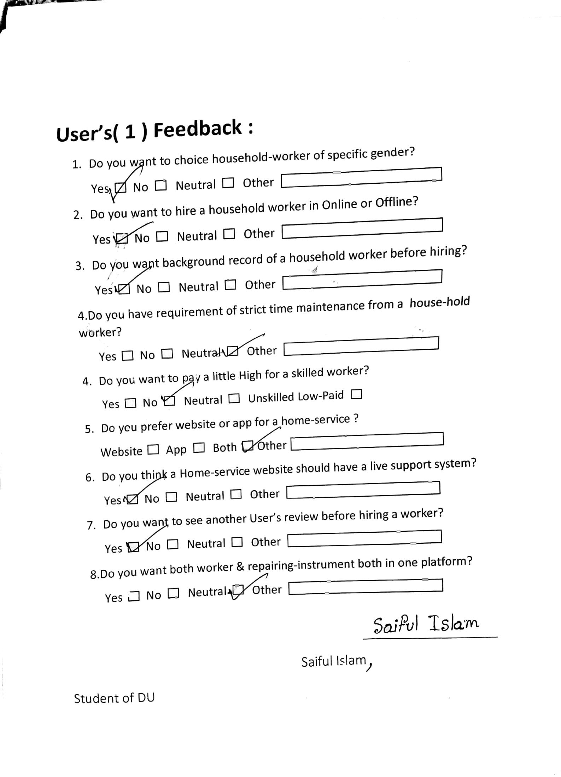

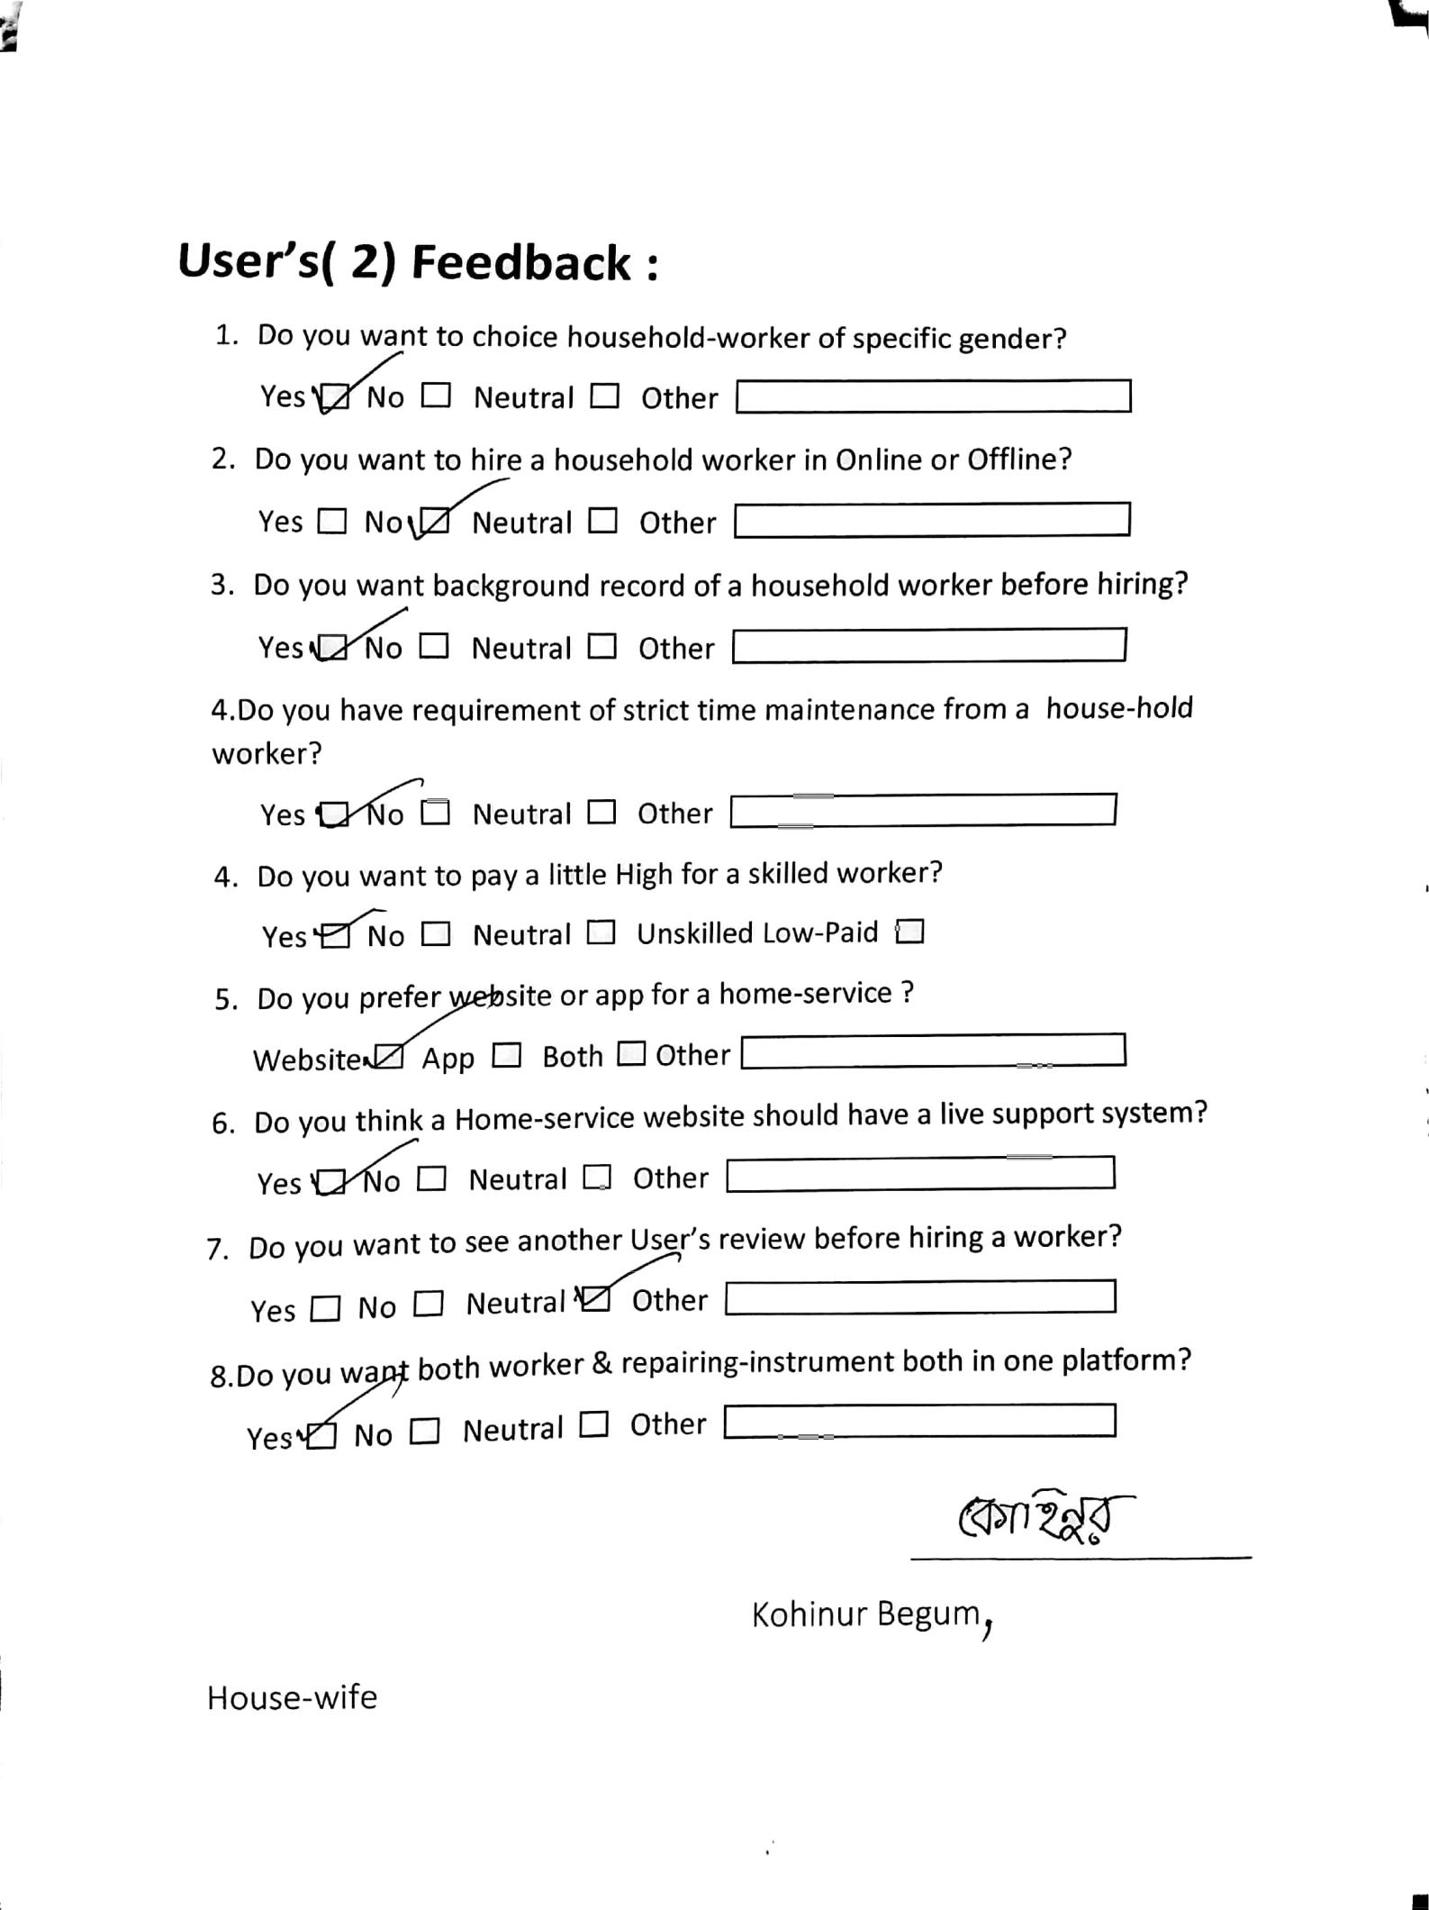

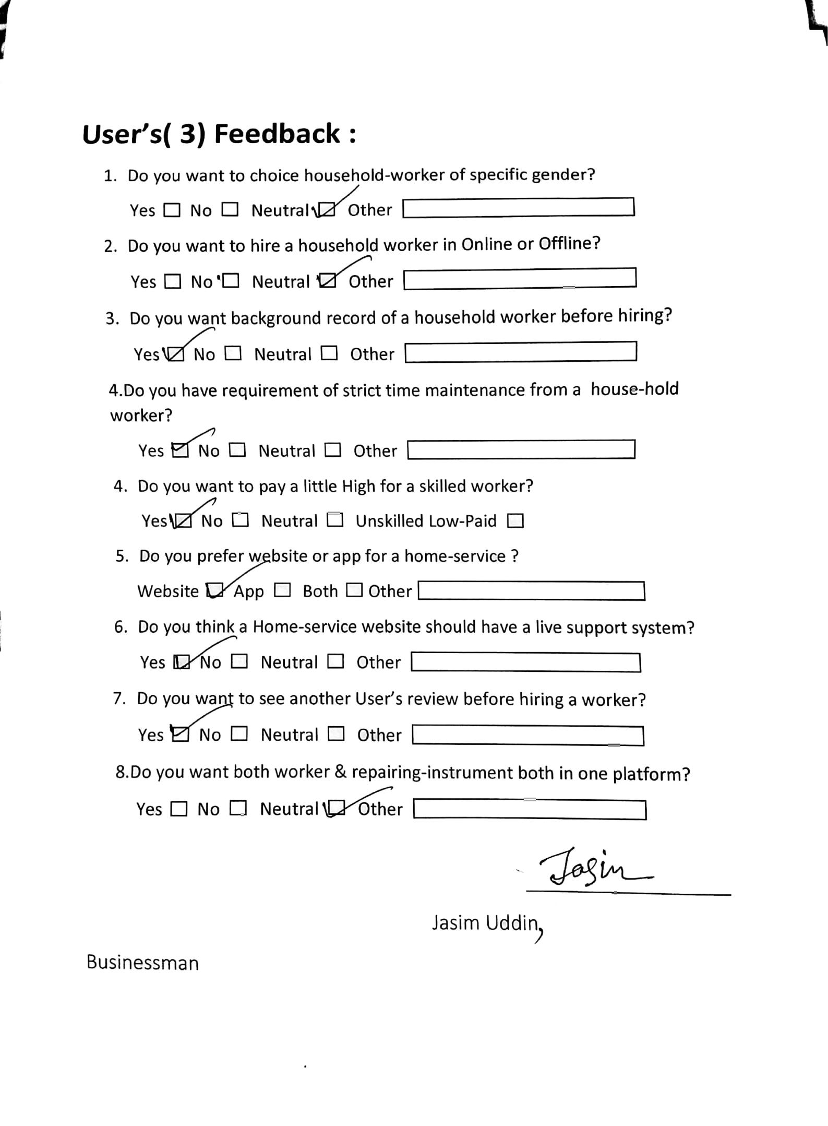

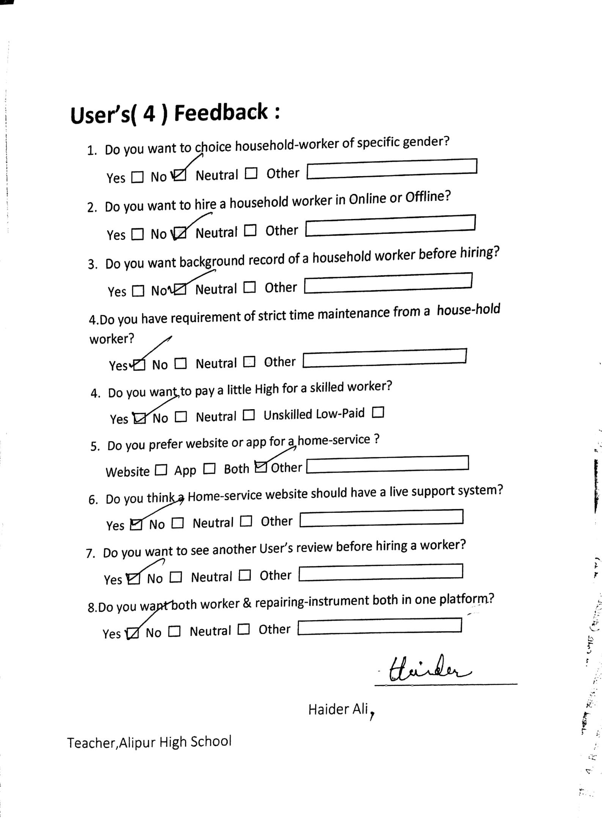

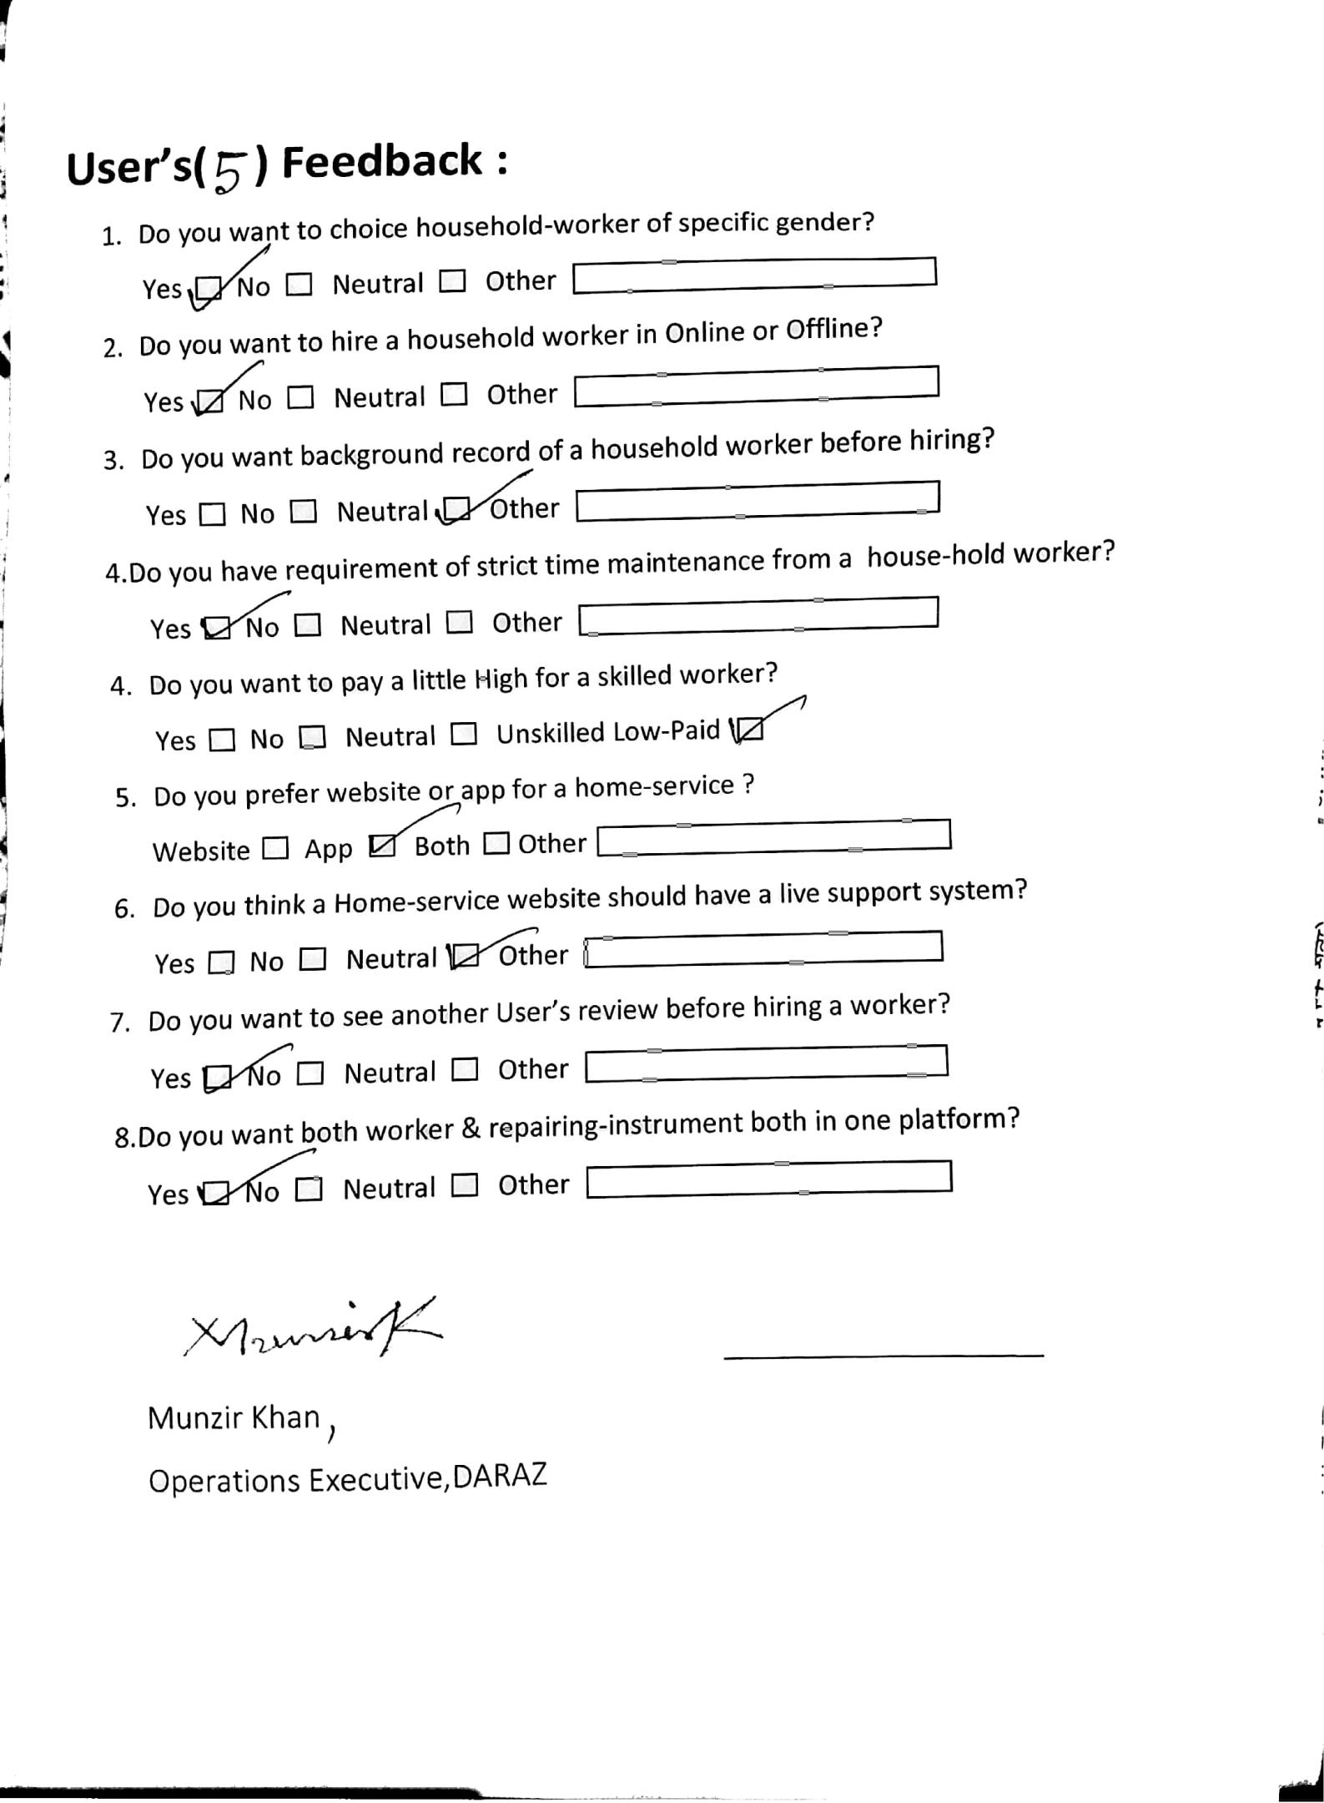

**Database Design(ERD)**

An **Entity–relationship model (ER model)** describes the structure of a database with the help of a diagram, which is known as **Entity Relationship Diagram (ER Diagram)**.

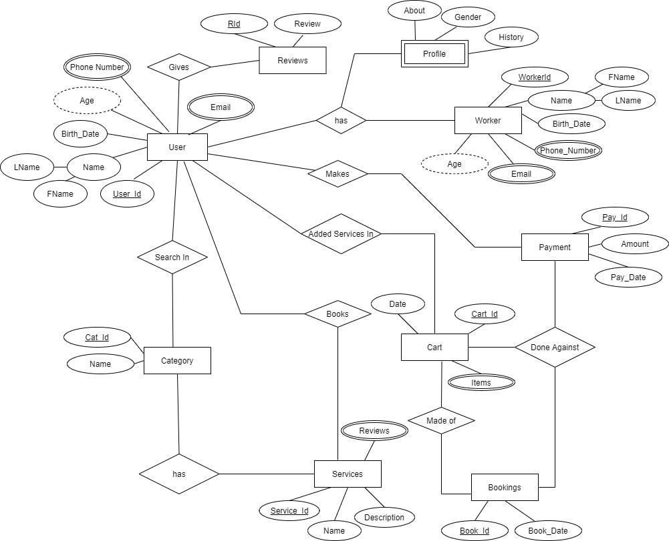

ER Diagram

**Data-Flow Diagram(DFD)**

DFD describes the processes that are involved in a system to transfer data from the input to the file storage and reports generation.

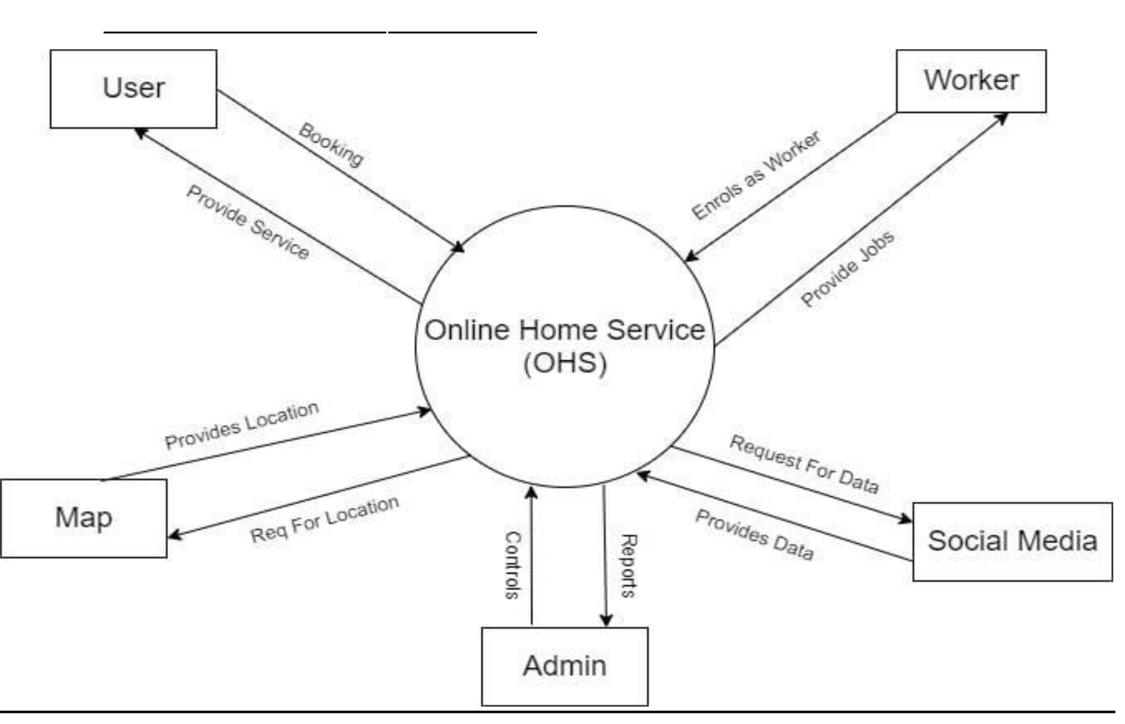Context-Level Diagram/Level -0 Diagram

Context-Level DFD



**Level-1 DFD**

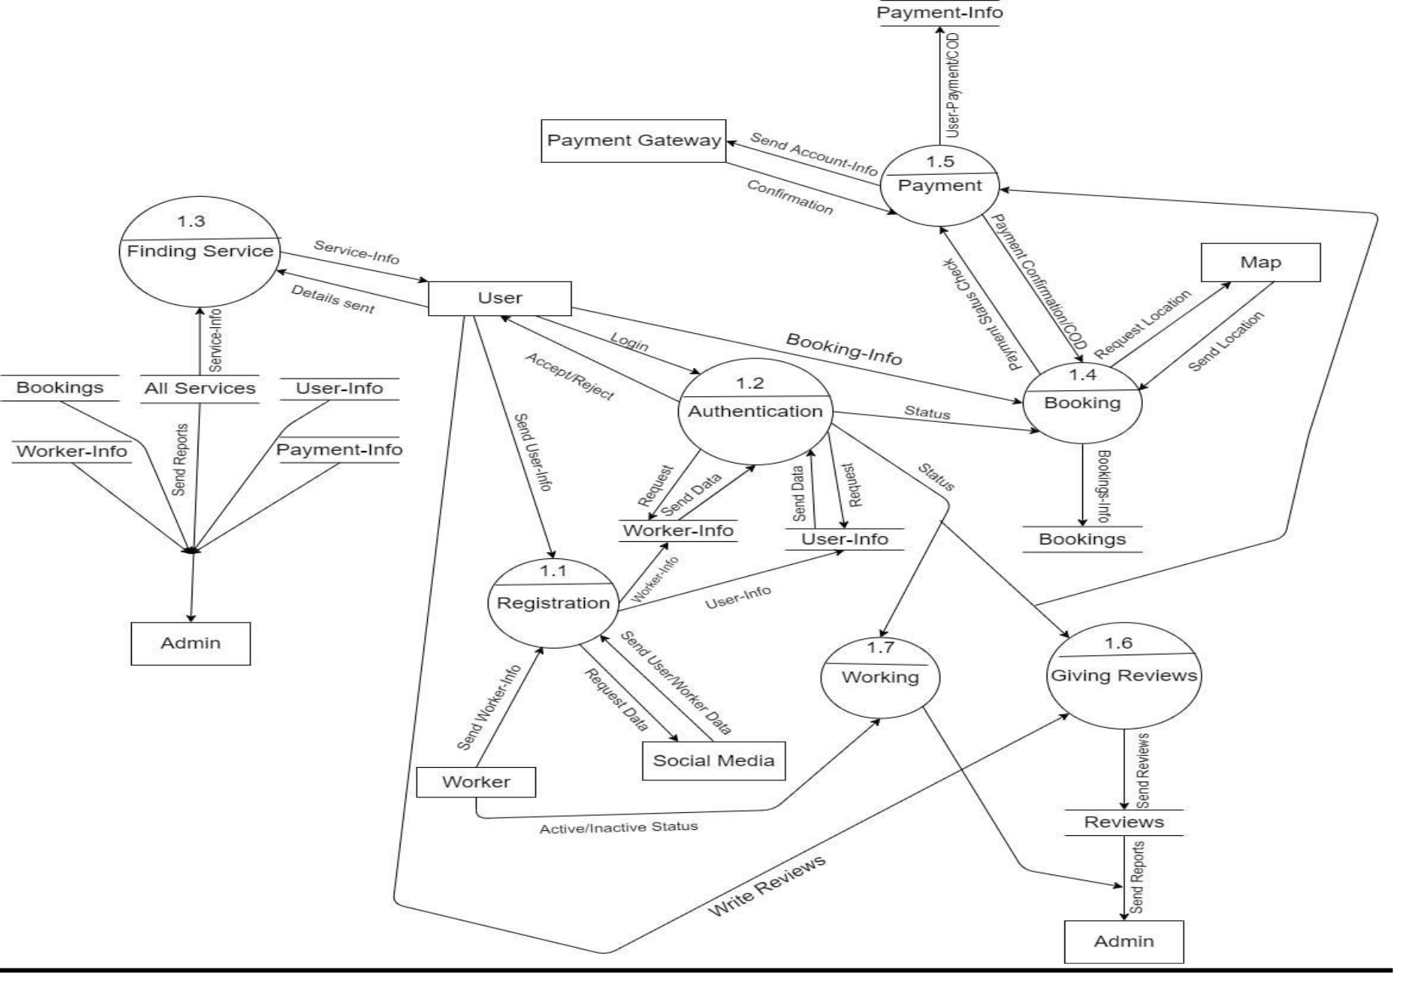

**Detail Functional Design**

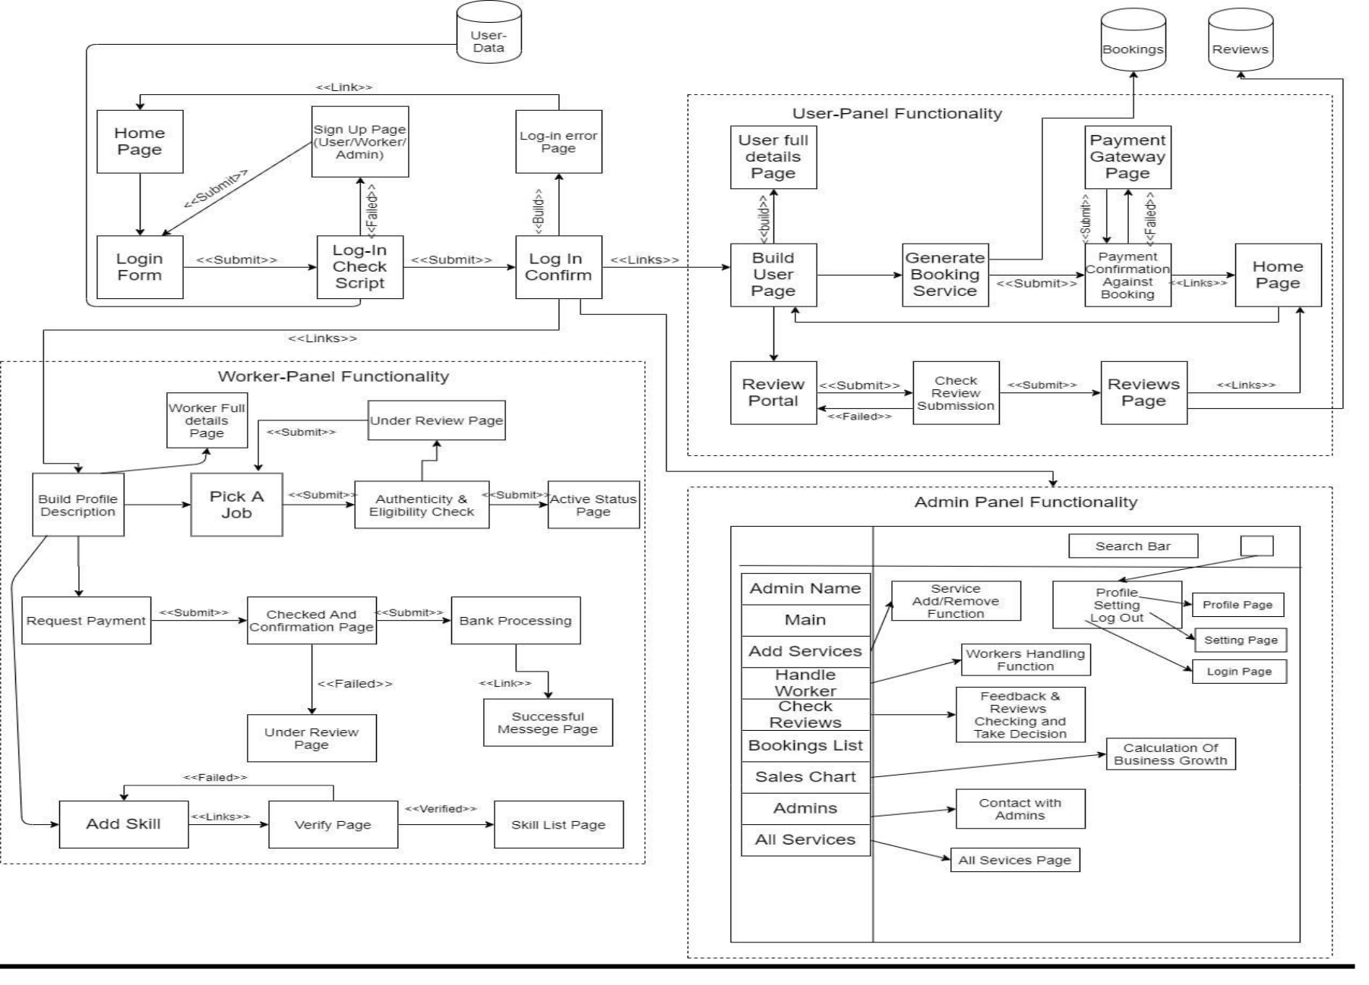

Functional Design **Use-Case Design**

A use case diagram at its simplest is a representation of a user's interaction with the system that shows the relationship between the user and the different use cases in which the user is involved.

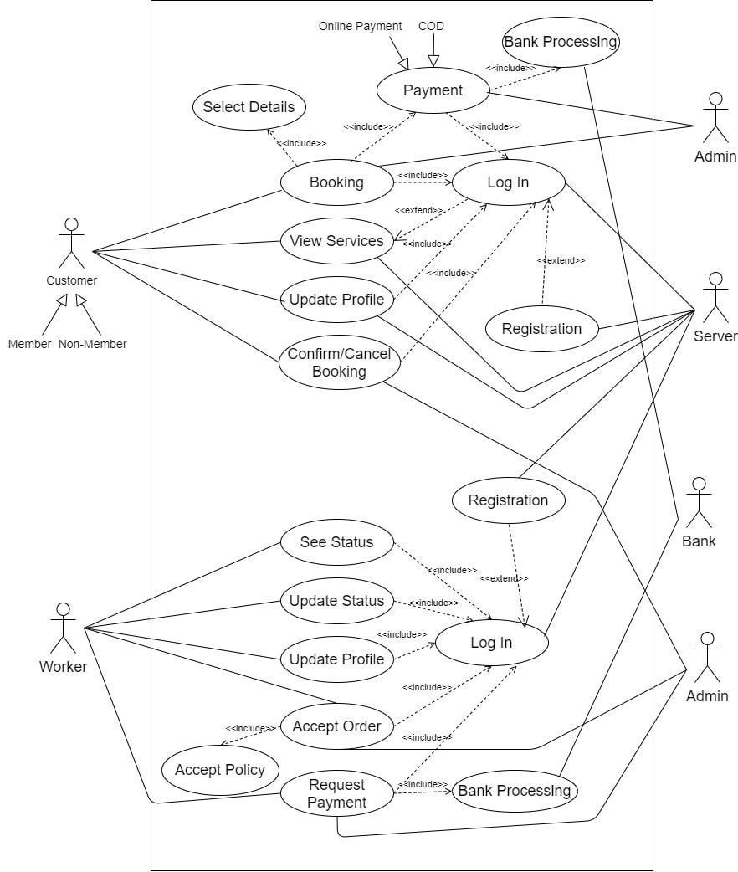

**Sketching The Application**

